**PARIS User Manual**

# **Design Concept**

It is not unusual when we find investors making investment decisions largely depend on subjective judgements, without awareness of what factors they are loading on and what risk levels they are exposed to. This is also an explanation for why often back testing results are unrepeatable. In designing and back testing trading strategies, users will inevitably tune strategy parameters to make performance look great. Sometimes it’s intentional as sell side analyst trying to sell their strategies to the clients, but more often it’s because investors/researchers lack the awareness of what actually made their performance look so great. As such they have no assurance of whether the spectacular performance will continue when the trading strategy is put to live use. Not to mention the continuous diligence required to constantly monitor a strategy’s strength and weakness after it is put to live trading. When it becomes too troublesome or technically impossible for investors to rationally monitor their trading decisions, the risk of them going for gut feelings increase.

To tackle this exact problem, I designed a ‘*Performance And Risk Integrated (Investment) System’,* or in abbreviation ‘PARIS’. PARIS is a system aiming to help users easily:

1. Perform Risk and Performance analysis on investors’ historical trades to assess their stock picking and market timing skills
2. Implement and back test new trading strategies/ideas
3. Perform risk and performance analysis on these trading strategies to know how and why they perform
4. Live trading of these outstanding trading strategies/ideas
5. Constant live monitoring of the portfolio holding and show live risk/performance metrics
6. Continuously update and build a complete price database.

# **System Explanation**

As shown in the Chart below, PARIS is made of seven closely inter-connected parts. This chapter starts with an overview of them, then followed by a detailed description. I’d recommend reading the detailed description section alongside the ‘PARIS – Complete Demonstration’ Jupyter Notebook file. Each module of the PARIS, excluding database, has a separate documentation file provided detailing code structure and all functionalities. User of this manual is encouraged to check out these detailed documentations when having any confusion. All python dependencies are described in detail in each documentation, please ensure those packages are installed before start running PARIS.

In case user lacks experience of the finance market: PARIS is an in-house investment management system not a broker! The current version of PARIS is built on brokers MetaTrader4 (MT4).

I have described in ‘Software_Configuration.docx’ file how to set up the MT4 software and provided a paper trading account for demonstration, please check it out before start using PARIS.

Not all python dependencies can be pip-installed, one special library Live Trading Assistant module heavily reliant on is DarwinEx Lab ZMQ Connector. Please check out Software_Configuration file for detail. Web link referenced here: <https://github.com/darwinex/dwx-zeromq-connector>

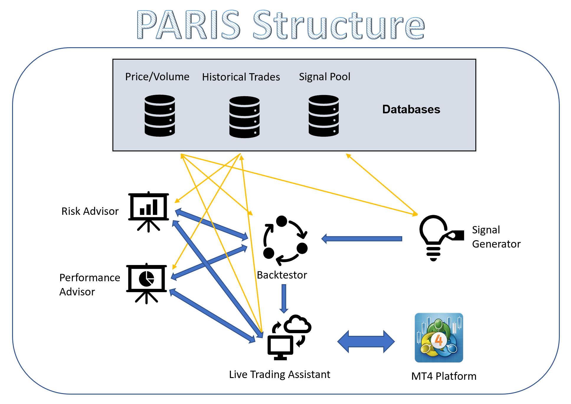

## Overview of modules:

1. A Database that contains different data sources, including market information (Price /Volume), User information (Historical trades) and strategy information (Signal Pool).
2. Signal Generator that calls on the price information from database, alongside other external factors, to make trading decisions and record the signal into the Signal Pool.
3. Backtestor calls price from Price database and either read from Signal pool or calls Signal Generator to form a back test of trading strategies. Then it passes the back-test result onto risk advisor and performance advisor to assess these metrics.
4. Risk Advisor can work out 13 different metrics. It by default runs analysis on users’ historical trades. It is connected to Backtestor to assess the risks of back-tested strategy. It is also connected to Live Trading Assistant to assess the risks of streaming portfolio holding every few seconds. It can be used to assess risks of hypothetical positions too.
5. Performance Advisor calculates several metrics to help investor understand where the returns come from. It is a derived class from Risk Advisor, so it has all the flexibility previously described of Risk Advisor.
6. Live Trading Assistant handles communication with the MT4 platform including requesting and receiving current position holdings, subscribe and collect live market data, trade executions. Live Trading App connects with Risk Advisor and Performance Advisor to give a live-updating demonstration of the portfolio risk metrics and return attributions. It also connects with the database to add latest price data into the database.

# Area of Improve